Information for Partners

YW Boston’s
Girls’ Health Program

Purpose and Benefits

Adolescent girls deserve comprehensive support during this critical developmental stage, where they are likely to face unique challenges to their mental, physical, and sexual health. Many schools and youth-serving organizations want to support girls’ health and wellbeing, but may lack the resources to run effective health programs.
YW Boston fills this gap by offering high quality, gender-specific, and culturally sensitive girls’ health education to schools and organization partners free of charge. The Girls’ Health program is one way that YW Boston achieves its mission of eliminating racism, empowering women, and promoting peace, justice, freedom, and dignity for all.
Through a health workshop series, middle school and high school girls are given the tools to make healthier choices, strengthen their wellbeing, and grow their potential.
- Learn about key health topics most relevant to them
In the program, girls will:
- Identify factors that affect their health and ways to take control
- Work together to practice newly acquired health skills

Program Structure
InIt Class of 2016

YW Boston’s Girls’ Health Coordinator will come to your school or organization to deliver a series of health workshop sessions, generally one per week for seven weeks. The group of girls in the workshop remains the same over the course of the series, in order to build trust and cooperation within the group.
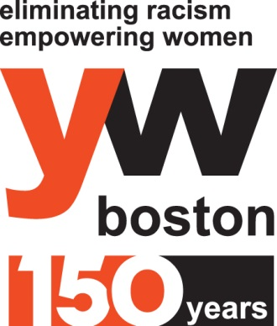
At the end of each workshop, girls fill out an evaluation form to track progress against the learning outcomes and evaluate the effectiveness of the program. At the conclusion of the series, each girl is asked to identify a health behavior to work on in the coming months; two to six months later, YW Boston follows up on their progress and assess long-term change in knowledge, attitude, and behavior.
All individual demographic information, including personal contact information, that is collected prior to and during programming is stored within YW Boston’s program database and is upheld to privacy standards. Please note that all YW Boston staff
are obligated to follow state regulations as mandated reporters
Curriculum Overview

Curriculum covers the topics most relevant to the comprehensive health of adolescent girls, and can be tailored to meet the needs of the age group and to comply with school requirements. The workshops include activities to accommodate varied learning styles.

Self-Esteem, Media & Body Image | - The role of self-esteem in a girl’s overall wellness  - Societal, cultural, relational, and media influences on self-perception  - Analyzing the perpetuation of gender roles and stereotypes in everyday media  - Strategies to build and maintain a healthy self-esteem and positive body image
Healthy Relationships | - External influences on interpersonal relationships  - Different forms of communication  - Strategies for dealing with conflict in any relationship  - How to identify an unhealthy or abusive relationship
Nutrition & Fitness | - Nutritional recommendations for adolescents and importance of healthy eating  - How to make healthy food choices when eating out and on a budget  - Concept of positive body image and its influence on weight management  - Fun fitness recommendations
Growth & Development | - Female anatomy and physiology  - Process of ovulation and menstruation  - Physical and emotional changes during puberty  - Hygiene basics
YW Boston also offers an optional sexual health workshop to schools that desire such curriculum to be covered. The material and approach can be tailored to the age group of the students.
Sexual Health  (7th and 8th grade and up) |  | - Definition and spectrum of sexuality, including gender roles, gender identity, gender expression, and sexual orientation  - Sexually transmitted infections  - Communication tactics in relation to safe decision making with one’s partner  - Introduction to protection methods  - Demonstration of male/female condoms, dental dams (8th grade and up)

2

Successful student experiences in Girls’ Health relies on a strong collaboration between YW Boston staff and partner schools and organizations. Partner responsibilities include:
Partner Responsibilities
- Identify girls from your school or organization to participate in YW Boston’s Girls’ Health workshops. To maximize the program’s benefits, a minimum of 10 girls should participate in each series.
- Notify program participants and parents/guardians of YW program, including a 2-6 month follow up (via phone, email or in person) prior to the start of workshop series
- Acknowledge that as part of YW Boston’s education and follow up purposes, YW Boston will retain any program participant information that it compiles during the series

Testimonials
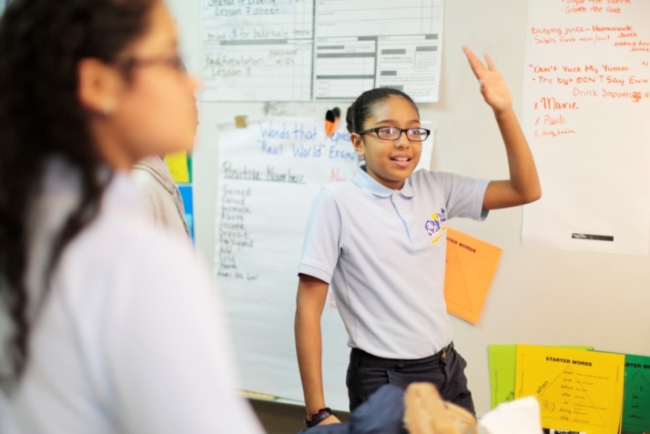

After YW Boston’s Girls’ Health workshops, girls report:
“I’ve changed how I feel about myself. I’m more confident and happy.”
“I have started eating more fruits, vegetables, and salads.”
“I’ve started trying to get more sleep.”
“I’ve started trying to talk with my mom about puberty, and I know how to deal with unhealthy relationships.”
Partner contacts report:
“The girls had a better understanding of themselves, and their peers. They grew individually and as a group. By the end of the program the girls were equipped with tools to be more effective leaders and were using what they learned in their surroundings.”
“Thank you so much for partnering with our organization. The girls who participated in the program not only had a blast but were able to learn about serious topics in a way that they were receptive to!”
“The middle school girls did not receive a health class/curriculum prior to our partnership with YW Boston. After the workshop series, I noticed girls talking about the fact that they were happy to have learned information about nutrition and body image. In addition, I know during some of their classes, especially during the sex education lessons, some of the myths about sex, puberty, etc. were broken down and explained. I know that was a huge benefit to this course.”

Contact Information

To discuss partnering with YW Boston to offer a Girls’ Health series, please contact: Brianna Moody, YW Boston Girls’ Health Coordinator, at 617-585-5409 or bmoody@ywboston.org. More information about YW Boston and the Girls’ Health program can be found at: www.ywboston.org/girlshealth.
3
4

