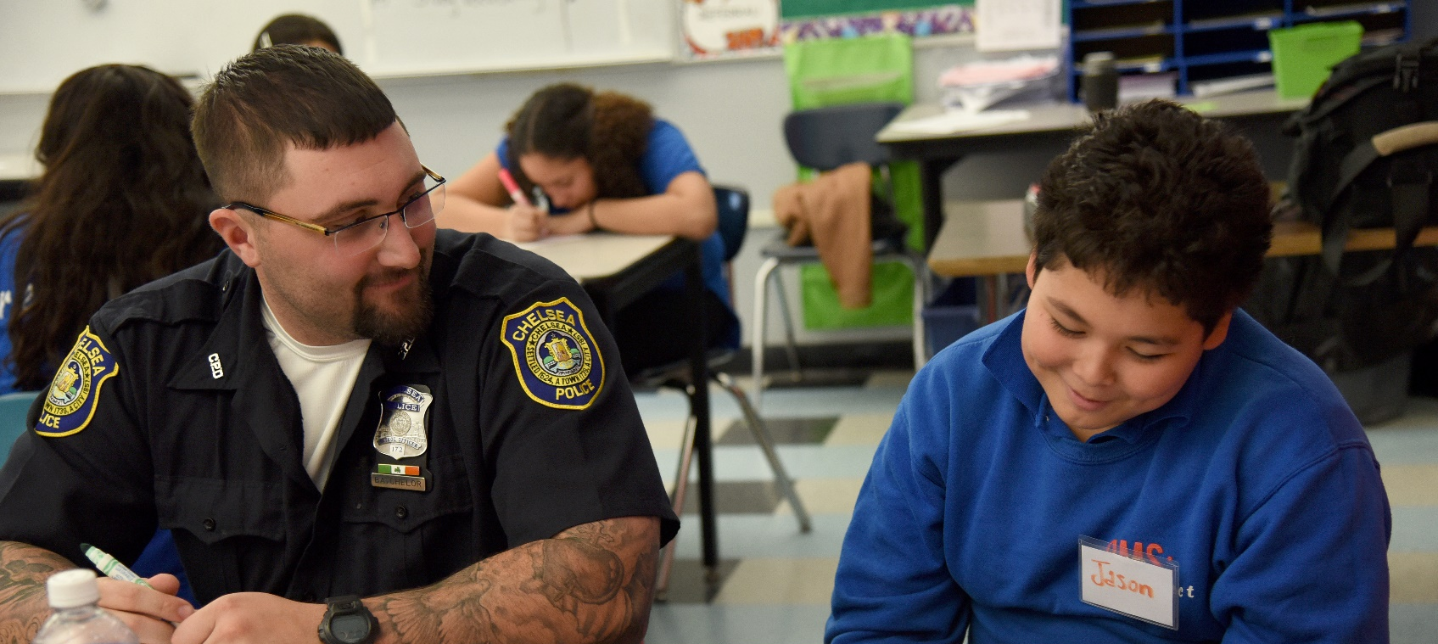
Information for Partners

YW Boston’s
Youth/Police Dialogues Program

Purpose and Benefits

Broken trust between police and young people decreases community safety and can have devastating consequences. Improving police-community relations remains challenging, particularly for communities of color that have suffered the consequences of this mistrust for generations. YW Boston’s Youth/Police Dialogues (YPD) provides a safe, structured way for young people and police officers to come together, speak openly, and rebuild trust.
- Have an opportunity to talk about and address negative experiences with police
In YPD, young people will:
- Break down stereotypes and form personal connections with officers
- Build greater trust of police and awareness of community safety
- Gain a sense of empowerment to make positive change in their community

Program Structure
InIt Class of 2016

YW Boston’s highly trained YPD facilitators will come to your school or organization to deliver a series of workshop sessions to a group of approximately 20 students at your school, generally one 70-minute session per week for 4-7 weeks.
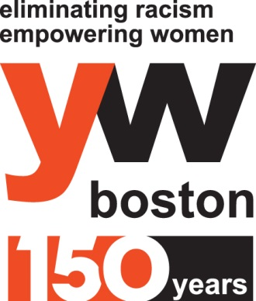
Through our partnerships with several local police departments, we will arrange for 4-6 officers to participate in the series.
Each workshop will include interactive elements as well as facilitated conversation. Students are asked to complete an evaluation form at the end of the workshop to assess learning outcomes and effectiveness.
Curriculum Overview

The 4-7 session YPD curriculum is carefully crafted to increase the level of trust and understanding between youth and police. It can be tailored to meet the needs of the age group of the youth participating.

Setting a foundation | - Youth get to know each other and what to expect from the series  - Create community agreements as a group  - Youth share how they feel about the police and the safety of their community
Exploring stereotypes | - Youth and police meet for the first time and do community building activities  - Discuss stereotypes each group has of the other, where they come from, and their impact on interactions
Switching roles | - Roleplay common youth/police interactions  - Youth learn what police may be thinking during stops  - Police gain understanding about common youth responses during stops
Community responsibility | - Discuss “stop snitching “culture, what it means, where it comes from  - Walk through “what would you do?” scenarios  - Discuss consequences of reporting and the meaning of community responsibility
Relationship-building | - Youth and police get to know each other through 1-on-1 conversations  - Life Mapping activity, which humanizes and builds personal relationships
Action plan | - Youth and police share key takeaways and how to share what they learned  - Identify how to be models for how police and youth should interact  - All participants make specific, personal commitment to change within their spheres of influence
Partner Responsibilities

Successful YPD series require strong collaboration between YW Boston staff and partner schools and organizations. Partner responsibilities include:
- Identify a primary contact for the YW Boston Youth/Police Dialogues Manager.
- Identify approximately 20 young people from your school or organization to participate.
- Ensure at least 70 minutes of time is protected for curriculum delivery, not including transition or set up time. An additional 30 minutes is needed before the first session for a pre-survey.

Schedule a Series

To set up Youth/Police Dialogues series, please contact: Mica Warton, YW Boston Youth/Police Dialogues Manager, at 617-585-5421 or mwarton@ywboston.org.
More information about YW Boston and the YPD program can be found at: www.ywboston.org/ypd.

