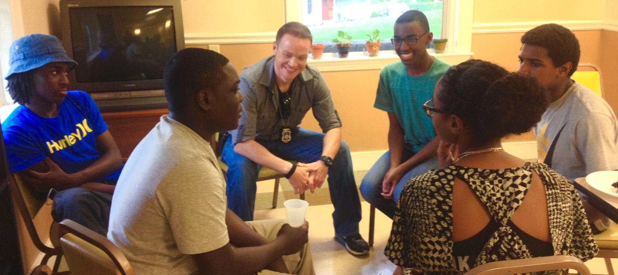
Information for New Sites

YW Boston’s
Youth/Police Dialogues (YPD)
A guide to bringing YPD to your community

Purpose and Benefits

Broken trust between police and communities decreases community safety and can have devastating consequences. Despite shared goal of safer neighborhoods, improving police-community relations remains challenging, particularly for communities of color that have suffered the consequences of this mistrust for generations. YW Boston’s Youth/Police Dialogues (YPD) program provides a safe, structured way for young people and police officers to come together, speak openly, and rebuild trust.
Based on the success of this program in Boston and overwhelming need across the country, we are encouraging other communities to bring YPD to their city. YW Boston will partner with new sites to set up the program for long-term success in improving police-community relations, community engagement, and community safety.

YPD benefits your community by: | - Increased trust between community and police  - Improved channels of communication between youth and police  - Police understand the community better  - Youth develop relationships with officer and are more willing to report a crime  - Increased sense of empowerment to make positive change

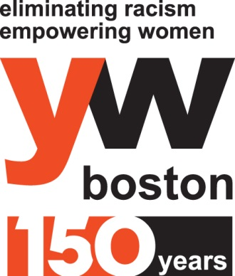
“The YPD program helps youth and officers to shed layers of misunderstanding and creates a neutral environment where we can just talk, talk for real, about the issues the youth are facing, and about the work we as officers are trying to do in the community. We walk away having a better understanding of each other. YPD helps us to eliminate the ‘us v. them’ mentality and realize we are in this together. We all want a peaceful, safe community.”

- Officer Israul Marrero, Boston Police Department
Program Structure

Youth/Police Dialogues take place where youth live and/or attend school. The participating group should be made up of approximately 20 young people, 4-6 police officers who serve in the same neighborhood, and 2 professional facilitators who guide discussions and learning activities. A YPD series consists of 4-7 sessions of approximately 1-2 hours each, generally 1 session per week for approximately 6 weeks.
The YPD curriculum is carefully planned to build trust, relationships, and understanding at a pace that is moderate enough to allow for deep experience, but fast enough to result in immediate action. Each session begins with a review of the ground rules for participation and an overview of objectives, ensuring that the conversation remains respectful and focused, and ends with a debrief, giving participants a safe opportunity to process any challenging emotions that arise from the conversation.

Session 1:  Setting the foundation | Youth get to know each other and learn what to expect from the series. Facilitators create community agreements that will create a space in which youth can be honest about the difficult topics that are covered. Facilitators guide youth in discussing how they feel about the police and the safety of their community.
Session 2:  Exploring stereotypes | Youth and police meet each other for the first time. They engage in community building activities. Then, they jump in to discuss stereotypes they have of each other, where those stereotypes come from, and how those stereotypes and unconscious biases impact outside interactions.
Session 3:  Switching roles | Participants roleplay common youth/police interactions. Youth act as the police officers, and vice versa. Youth learn about what police may be thinking during stops, as well as some relevant laws and jurisdiction (i.e., transit police versus city police). Police come to better understand common youth responses during stops, and both groups are better equipped for future interactions.
Session 4:  Community responsibility | Youth and police talk about the “stop snitching” culture, what it means, and where it comes from. In small groups, youth and police walk through “what would you do?” scenarios, and discuss fears and barriers to reporting crimes as well as the positive and negative consequences of a decision to report or not to report. The group discuss what community responsibility means to everyone in the room.
Session 5:  Relationship-building | Youth and police learn about each other through 1-on-1 conversations and team-building activities such as Life Mapping, where youth map their lives out as a way to share dreams and goals for their futures, and police officers map backwards to share how and why they chose the path they did. This session’s focus is relationship building and humanization.
Session 6:  Action plan | Youth and police talk about their key takeaways and how to bring what they’ve learned back to the community. They also talk about how they can be models for how police and youth can and should interact. They each make a specific, personal commitment to be the change within their sphere of influence.
2
2
Partner Responsibilities

For the Youth/Police Dialogues program to be successful in a new community, we rely on strong collaboration with a host partner organization at the new site.
YW Boston will provide to you:
- Facilitator screening and training, including: application screening and support; three information sessions; two training sessions; and all related materials, including a slide deck and trainer guides.
- Coordinator support and training, including: support in identifying YPD coordinator(s); training for coordinator(s) around facilitator coaching and support, working with the local police department, managing partnerships with youth serving organizations, and solving common logistical problems; and all relevant documents and better practices outline.
- Curriculum access and support, including: access to our data-driven curriculum and facilitator guides; and consultation with someone on your staff and a minimum of 2 local youth to make curriculum adjustments necessary to ensure relevance toy our specific community.
- Data support, including: assessments and data analysis for each YPD series.

As a host partner organization, your responsibilities include:
- Select a staff person or volunteer to serve as the primary contact for YW Boston’s Youth/Police Dialogues manager. This person should be prepared to devote approximately 10 hours of coordination time per month for at least 3 months.
- Secure expressed interest from at least one of the police departments in your community and several youth-serving organizations.
- Identify and recruit a minimum of 7 (and up to 25) volunteer facilitators to go through a selection process and training. Facilitators should represent a diverse group with respect to gender, race, and age, and at least half of the group should have deep roots in your community.
- Submit payment for the series as per the fee structure below.
- At the conclusion of the series, complete assessment forms and submitting data to YW Boston.

Fee Structure

For partner organizations in the Greater Boston area, YW Boston offers an introductory YPD series, administered by YW Boston staff and facilitators, at a cost of $1,500.
After the introductory series, each subsequent series incurs a fee of $3,000, which reflects the additional cost of training facilitators and building up the necessary partnerships and infrastructure at your site.
The total cost for setting up robust YPD program at a new site in the Greater Boston area comes to between $16,000 and $20,000. Fees go to paying for staff time, materials, and evaluation. Host partners outside the Greater Boston area may incur additional costs for travel.
YW Boston can work with your organization to facilitate cost and resource sharing among other new YPD sites in your area.
3

FAQs

1) Who facilitates the dialogues? Can we select our own facilitators?
Facilitators have a wealth of experience and come from a variety of professional sectors. Facilitators are YW Boston staff and highly trained volunteers. We work with your organization to select facilitators that are the best fit for your needs.
2) We have identified more than 20 youth that we’d like to participate, can our groups be larger than that?
For trust and genuine relationship building to occur, group size is limited to a minimum of 15 and a maximum of 22. However, we can accommodate a larger number of participants by offering multiple dialogue series at one time.

3) How do we get police officers involved? Which ones will participate?
We work with you to build a partnership with your local police department. Department administrators will be asked to assign officers working in the neighborhood to participate, so that the relationships formed in YPD will continue outside of the dialogues.
4) How do I know this program is effective?
The YPD program has been evaluated by YW Boston staff and independent academic researchers. Recent data shows that after a YPD series:
- 71% of police say they now approach policing differently
- 89% of youth say they would report a crime to a police officer
- 94% of youth feel comfortable when they see a police officer
Youth participant, Grade 7, before YPD: “I feel ok, but because of things that happened, I don’t trust them fully. I have little faith in them.”
Same participant, after YPD: “I feel like it has changed me. Because I’ve gotten to know more about cops. Also, not to judge based on one thing and to give second chances. Don’t let people stereotype you, and don’t judge cops based on another cop.”
Getting Started

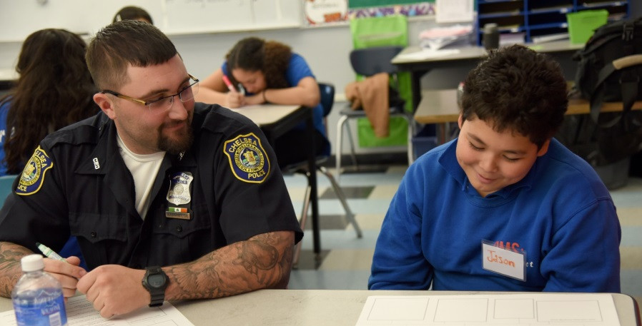
YW Boston is prepared to assist with setting up YPD in new sites throughout the year.
4

Requests to schedule a YPD series may be submitted by contacting:

Mica Warton, Youth/Police Dialogues Manager, at 617-585-5421 or mwarton@ywboston.org.
4

