Employer Commitment

YW Boston’s
LeadBoston

YW Boston’s LeadBoston program is an 11-month executive leadership program running January through November, requiring a commitment of : 9 monthly program days (9:00am - 5:00pm, one Wednesday per month), a half-day orientation, an overnight retreat, and an evening graduating/closing celebration. To learn more about LeadBoston, please visit www.ywboston.org/leadboston.
Commitment Form
I/We ____________________________________________________ am/are the employer of
^{(Employer)}
______________________________who is applying for admission to the LeadBoston program.
^{(Applicant)}
I/we agree to sponsor the applicant in the LeadBoston program by:
- Providing the applicant with the time off of work to participate in all required LeadBoston program activities (program days and retreat). AND

- Paying $____________________ toward the applicant's non-refundable and non-transferable tuition, as specified in the fee scale on page 2. If the employer is not financially supporting the applicant, please enter “0” in the above line.

Sponsor Name: _________________________________ Title: ________________________________
Mailing Address: _______________________________________________________________________
Phone: ______________________________ Email: __________________________________________
Billing Information (if different from above)
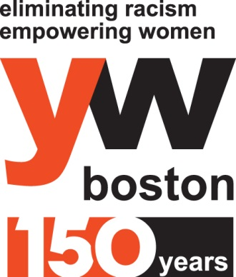
Billing Contact Name: ___________________________ Email: ________________________________
Billing Organization: _________________________________________________
Billing Address: _____________________________________________________
Billing Phone: _________________________________ _
Signature: __________________________________________________________
Date: ______________________________________________________________
Fee Scale
Corporation (for profit)
25 employees or more: $6,500
Fewer than 25 employees: $3,500
Non-profit Organization or Public Agency
100 employees or more: $6,500
Between 26 and 99 employees: $3,500
Fewer than 25 employees: $2,000

How to Submit
Submit this completed form by email to Mu-Chieh Yun, LeadBoston Coordinator, at myun@ywboston.org, or fax to 617-585-5499.
With questions, please call Mu-Chieh at 617-585-5431.

Please Note
Attendance at 80% of program days is a mandatory component of this program. If a participant fails to meet the attendance requirement, they will be asked to leave the program. Tuition will not be reimbursed.
Upon applicant’s acceptance, the employer will be invoiced and payment will be due on January 30, 2017. All tuition and fees are non-refundable.

